**ASIAN COLLEGE OF HIGHER STUDIES**

**(Affiliated to Tribhuvan University)**

**Ekantakuna, Kathmandu**



**LAB REPORT**

**OF**

**“Operating System”**

**Submitted by**

**Shradha Khatiwada (211843)**

**Fourth Semester**

**Submitted to**

**Birendra Yadav**

**ACHS, Lalitpur**

# Basic Linux Commands

## lscpu:

Interpretation: Displays information about the CPU architecture.

Command: lscpu

Output:

## lspci:

Interpretation: Displays information about PCI buses in the system and devices connected to them.

Command: lspci

Output:

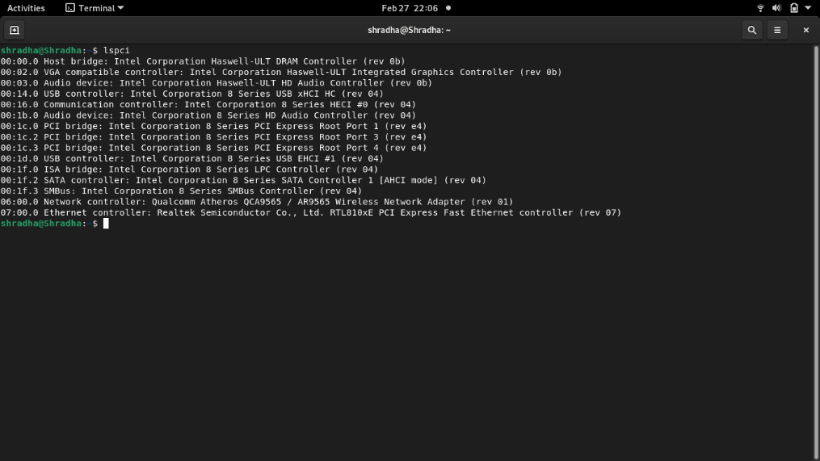

## su -:

Interpretation: Gives superuser login shell. The user is required to enter superuser password.

Command: su -

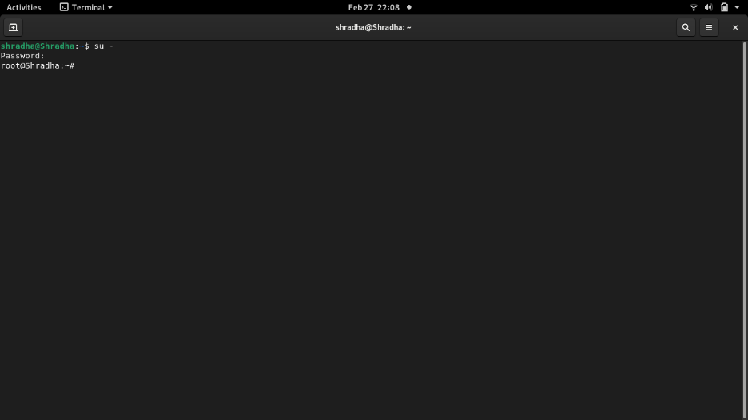Output:

## df:

Interpretation: Displays the amount of space available on the file system containing each filename argument. If no file name is given, the space available on all currently mounted file systems is shown.

Command: df

Output:

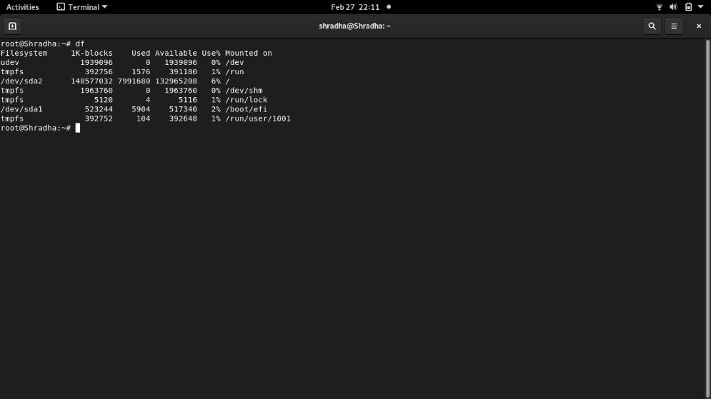

## fdisk -l

Interpretation: List the partition tables for the specified devices.

Command: fdisk -l

Output:

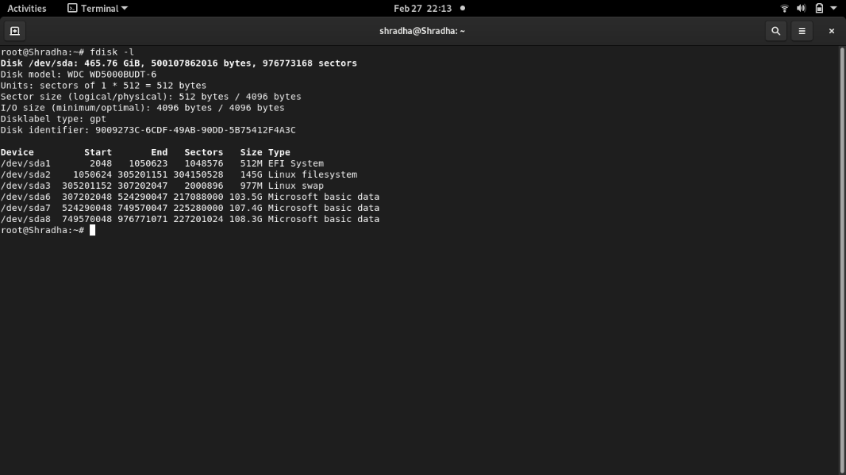

## free

Interpretation: Display amount of free and used memory in the system.

Command: free

Output:

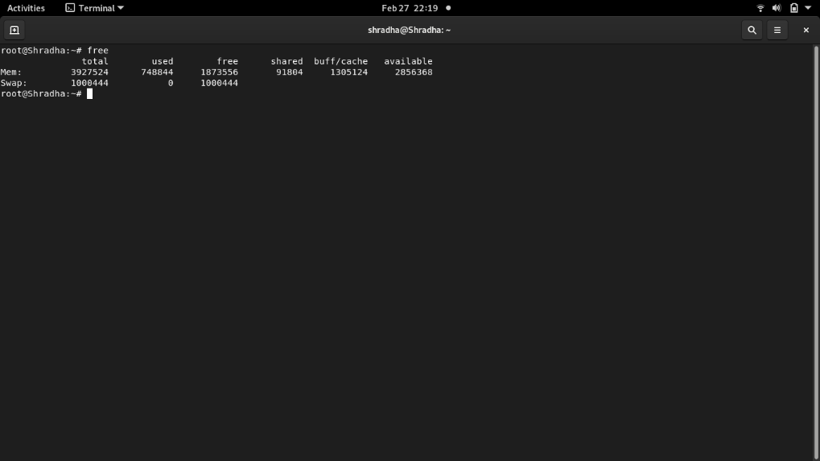

## dmidecode -t processor:

Interpretation: Dumps the computer's DMI (some say SMBIOS) table contents in a human-readable format and -r processor allows to dump the processor’s information.

Command: dmidecode -t processor

Output:

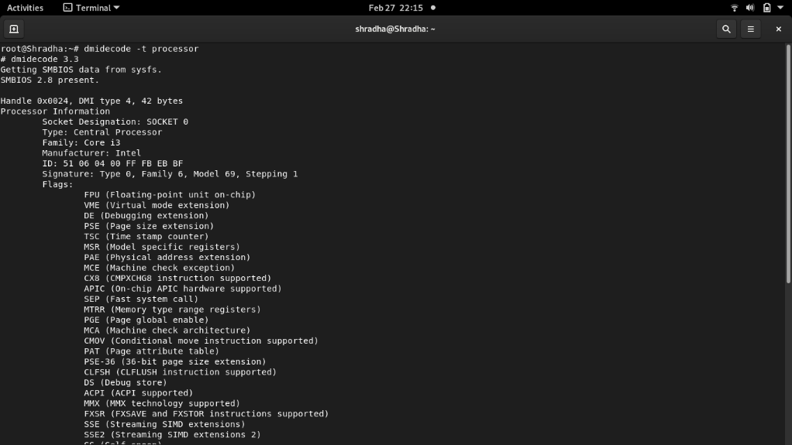

## dmidecode –t memory:

Interpretation: -t memory allows to dump the memory devies’ informations.

Command: dmidecode -t memory

Output:

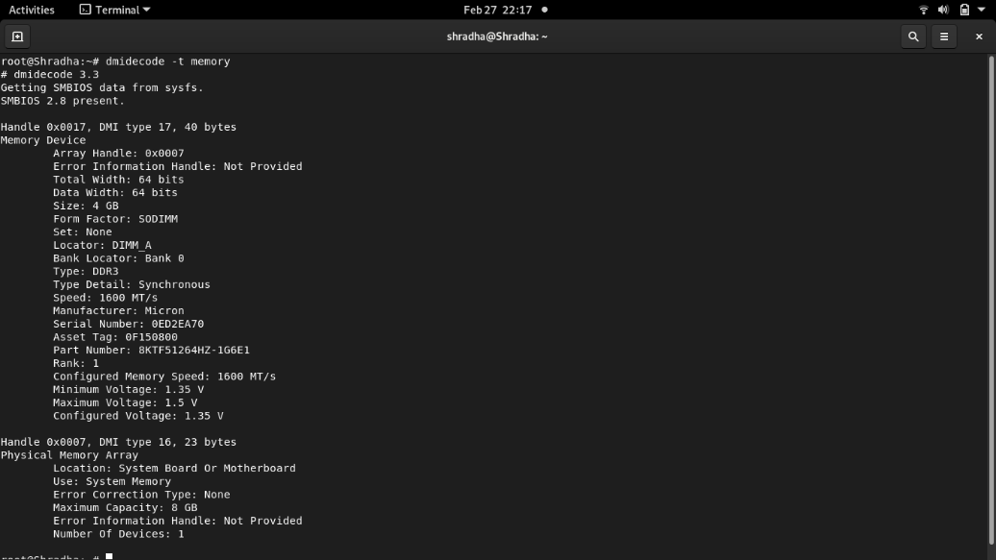

## dmidecode –t bios:

Interpretation: -t bios allows to dump the BIOS Information.

Command: dmidecode -t bios

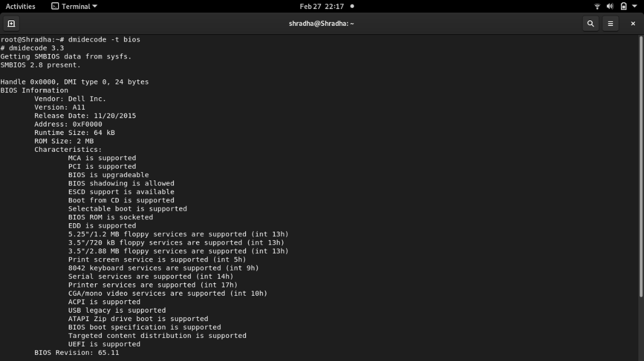Output:

## nslookup achsnepal.edu.np:

Interpretation: Query Internet domain name servers interactively.

Command: nslookup mergedtech.com

Output:

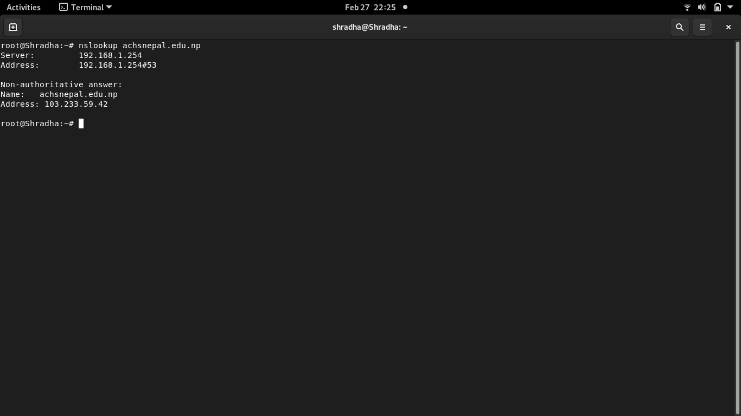

## exit:

Interpretation: Logs the current user out or the terminal itself.

Command: exit

Output:

## cat

Interpretation: View the content of the file.

Command: cat filename.ext

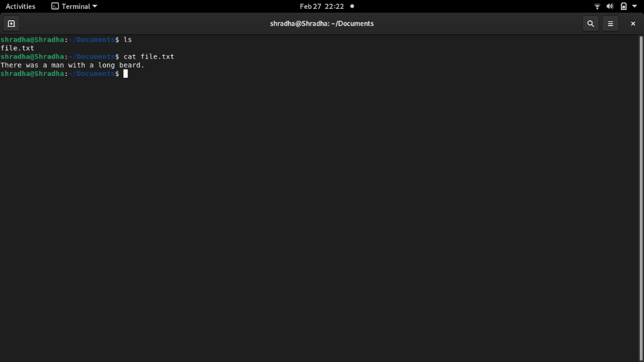Output: